✅ 1. Random Forest (Bagging)

📘 Definition:
An ensemble of Decision Trees where each tree is trained on a random subset of data and features (bootstrap aggregating = bagging).

🧠 Intuition:
Reduces overfitting by averaging many uncorrelated trees.

🧪 Code:
from sklearn.ensemble import RandomForestClassifier, RandomForestRegressor

clf = RandomForestClassifier(n_estimators=100) # For classification

reg = RandomForestRegressor(n_estimators=100) # For regression

✅ Advantages:
- Reduces variance and overfitting
- Handles missing values
- Works for both regression and classification

❌ Disadvantages:
- Slower than individual trees
- Less interpretable

📈 Use Case:
Fraud detection, house price prediction, medical diagnosis

📍 When to Use:
When data has non-linearity, noise, or many features

🚧 Limitations:
- Less transparent
🔁 Alternative: Use Explainable AI tools (SHAP, LIME) or simpler models
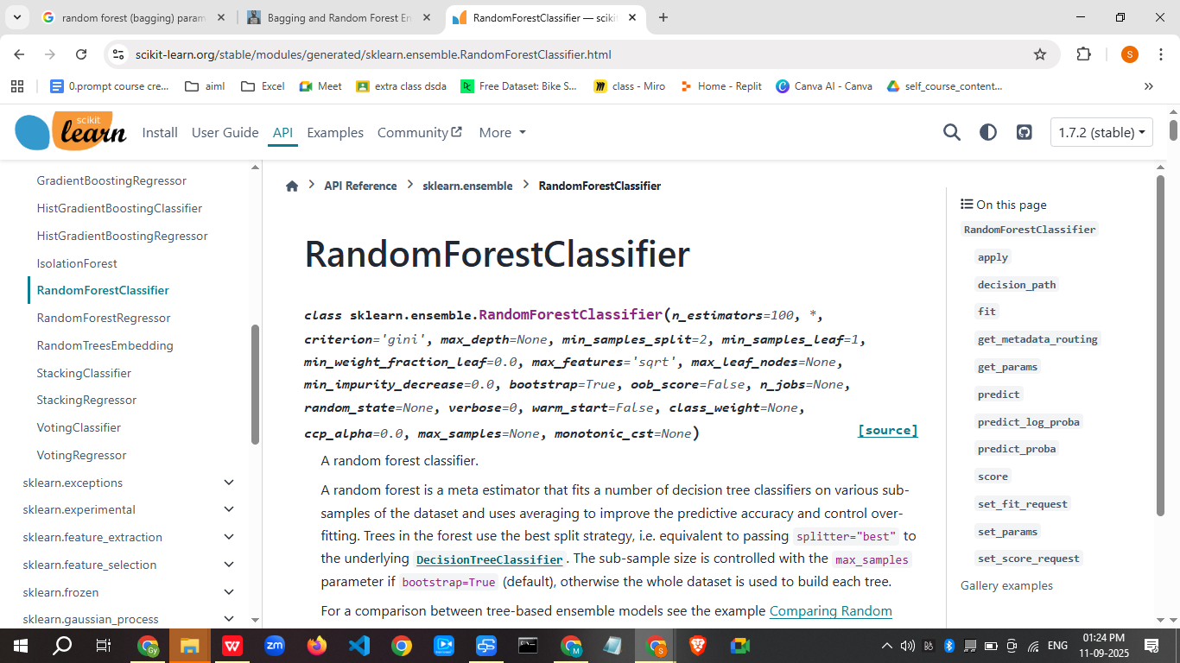

https://scikit-learn.org/stable/modules/generated/sklearn.ensemble.RandomForestClassifier.html

Key parameters for a Random Forest (bagging) algorithm include n_estimators (number of trees), max_depth (maximum tree depth), max_features (number of features at each split), min_samples_split (minimum samples for a node split), min_samples_leaf (minimum samples for a leaf node), and bootstrap (whether to sample with replacement). Tuning these parameters helps control model complexity, prevent overfitting, and improve predictive accuracy by balancing the ensemble of decision trees
https://machinelearningmastery.com/bagging-and-random-forest-ensemble-algorithms-for-machine-learning/

Parameters for Tree Structure and Complexity
- max_depth: Controls the maximum depth of individual decision trees, limiting the complexity of the model and reducing overfitting.
- max_leaf_nodes: Specifies the maximum number of leaf nodes in each tree.
- min_samples_split: Defines the minimum number of samples required to split an internal node.
- min_samples_leaf: Sets the minimum number of samples that must be at a leaf node.
Parameters for the Ensemble
- n_estimators (number of base learners): The total number of decision trees in the forest. More trees generally lead to a more robust model with reduced variance, but also increase computational cost.

- max_features: The number of features to consider when looking for the best split at each node. A smaller value increases randomness and reduces correlation between trees.

- max_samples: The fraction of the original dataset to be given to any individual tree.

Parameters for Bagging Process
- bootstrap:
A boolean parameter that determines if bootstrap aggregating (bagging) is used. If set to False, each tree is trained on the entire dataset, but by default, it's set to True.
- bootstrap (sampling with replacement):
When True, the model creates bootstrapped datasets by randomly drawing samples from the original dataset with replacement for each tree, introducing variation.
Key Concepts
- Out-of-Bag (OOB) Error:
A method of estimating model error by using the data samples not included in a tree's bootstrap sample. This provides an estimate of the model's performance without needing a separate validation set.
- Variable Importance:
Random forests can be used to estimate the importance of each feature by measuring the impact of permuting a feature's values on the OOB error.

—-------------

✅ 2. AdaBoost (Adaptive Boosting)

📘 Definition:
Sequentially builds models that focus on the mistakes of previous models, adjusting weights of misclassified instances.

🧠 Intuition:
Each new model tries to correct the errors of the previous one.

🧪 Code:
from sklearn.ensemble import AdaBoostClassifier, AdaBoostRegressor

clf = AdaBoostClassifier(n_estimators=50)
reg = AdaBoostRegressor(n_estimators=50)

✅ Advantages:
- Simple & effective
- Works well with weak learners (e.g., shallow trees)

❌ Disadvantages:
- Sensitive to outliers
- Can overfit if not tuned

📈 Use Case:
Credit scoring, anomaly detection

📍 When to Use:
When base model is weak and you want to improve it via boosting

🚧 Limitations:
- Struggles with noisy data
🔁 Alternative: Use Gradient Boosting or more robust boosting techniques
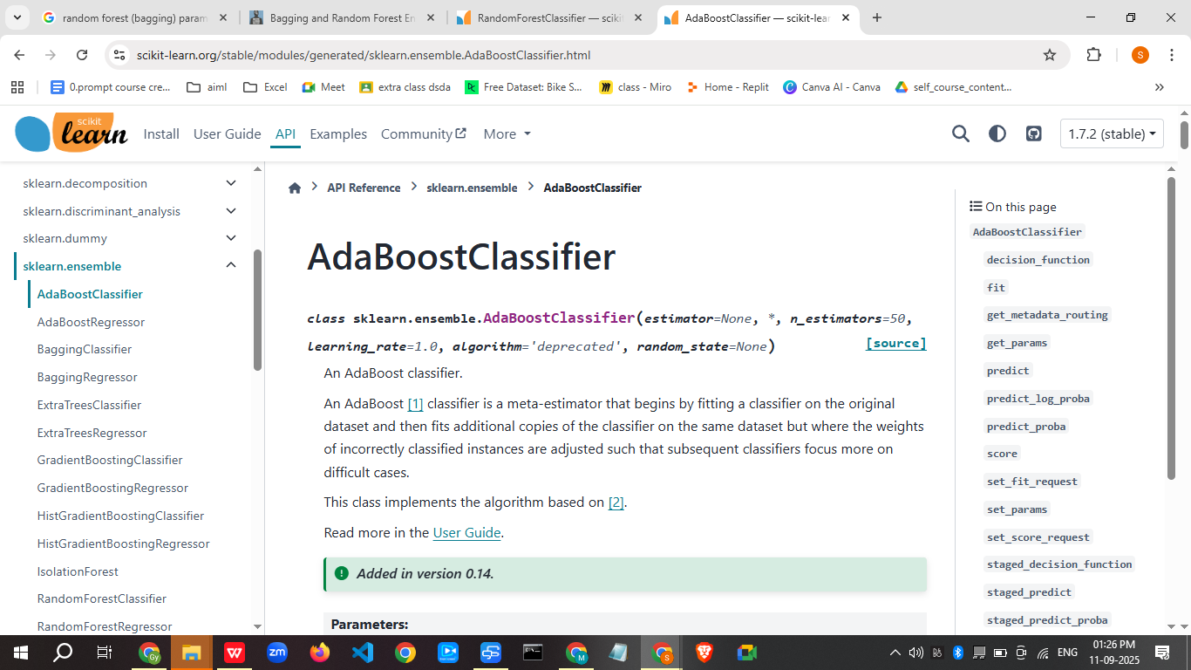
https://scikit-learn.org/stable/modules/generated/sklearn.ensemble.AdaBoostClassifier.html

Perfect 👍 Here’s a Parameter Impact Table for AdaBoost, so you can quickly see how increasing or decreasing each parameter affects the model.

📊 AdaBoost Parameter Impact Table
Parameter | What It Controls | If Increased | If Decreased | Notes / Tuning Tip
n_estimators | Number of weak learners (iterations) | - Lower bias (better fit)- Risk of overfitting- Longer training time | - Higher bias (underfitting)- Faster training | Tune together with learning_rate. Typical: 50–500
learning_rate | Contribution weight of each weak learner | - Faster learning- Can overfit quickly if too high | - Slower learning- Needs more trees- Improves generalization | Typical: 0.01–1.0. Lower rate + higher estimators = stable
base_estimator.max_depth | Depth of decision tree stump | - Captures more complex patterns- Higher variance (overfit risk) | - Simpler model- Higher bias (underfit) | Default is 1 (decision stump). Try 1–3 for balance
base_estimator.min_samples_split | Minimum samples to split a node | - Fewer splits → simpler tree- May underfit | - More splits → complex tree- Risk of overfitting | Use with max_depth for regularization
base_estimator.min_samples_leaf | Minimum samples per leaf | - Larger leaf size → smoother model, less variance | - Smaller leaf size → high variance, overfit risk | Useful for noisy data
algorithm (SAMME vs SAMME.R) | Type of boosting | - SAMME.R: Uses probabilities, faster convergence | - SAMME: Uses labels only, slower, may need more estimators | Use SAMME.R unless base learner lacks predict_proba
random_state | Controls randomness (reproducibility) | – | – | Doesn’t affect performance, only results reproducibility

🎯 Rules of Thumb
- Start with Decision Stump (max_depth=1) as base estimator.
- Use learning_rate=1.0 and n_estimators=50 as baseline.
- If underfitting → increase n_estimators or base tree depth.
- If overfitting → reduce max_depth, lower learning_rate, or increase min_samples_leaf.
- Always tune n_estimators and learning_rate together.

👉 Would you like me to also create a flowchart-style tuning guide (step-by-step decisions: if underfitting → adjust X, if overfitting → adjust Y)? That way it becomes like a quick cheat sheet for interviews/teaching.

✅ 3. Gradient Boosting Machines (GBM)

📘 Definition:
Boosting technique that minimizes the loss function using gradient descent.

🧠 Intuition:
Each tree corrects the residuals (errors) of the previous tree.

🧪 Code:
from sklearn.ensemble import GradientBoostingClassifier, GradientBoostingRegressor

clf = GradientBoostingClassifier()

reg = GradientBoostingRegressor()

✅ Advantages:
- High accuracy
- Customizable loss functions

❌ Disadvantages:
- Slower training
- Sensitive to overfitting

📈 Use Case:
Ranking systems, insurance claim prediction, click-through rate prediction

📍 When to Use:
When performance is more important than speed

🚧 Limitations:
- Needs careful tuning
🔁 Alternative: Use XGBoost or LightGBM (faster, optimized)
A Gradient Boosting Machine (GBM) is a powerful machine learning technique that combines many weak prediction models (typically decision trees) to create a highly accurate ensemble model. It works by sequentially building models to correct the errors of the previous ones, minimizing a loss function to improve accuracy for both regression and classification tasks on structured data. Key aspects include sequential training, predicting residuals instead of the target directly, and using hyperparameters like learning rate and tree depth to control model complexity and prevent overfitting.
How Gradient Boosting Works
- 1. Initialization:
The process starts with a simple base model, often a constant prediction value.
- 2. Error Calculation:
The difference between the actual values and the current model's predictions (the errors or residuals) is calculated.
- 3. Sequential Model Building:
A new weak learner (e.g., a decision tree) is trained to predict these residuals, not the original target variable.
- 4. Ensemble Combination:
The new model's predictions are added to the ensemble, weighted by a small "learning rate" or "shrinkage" factor. This shrinkage controls how much each new tree contributes to the overall model, helping to prevent overfitting.
- 5. Iteration:
This process repeats, with each new model focusing on the errors of the ensemble built so far, gradually refining the overall prediction.
- 6. Stopping:
Training continues until a specific condition is met, such as a predefined number of trees being reached or when performance on a validation set starts to decrease (early stopping).
Key Characteristics
- Ensemble Method:
It combines multiple models (weak learners) into a single stronger model.
- Sequential Learning:
Models are built one after another, with each new model learning from the mistakes of the previous ones.
- Loss Function Minimization:
The core idea is to iteratively reduce a loss function, which quantifies the model's error.
- High Accuracy:
It is known for achieving state-of-the-art results on many structured data problems.
- Hyperparameter Tuning:
The performance and ability to avoid overfitting depend on carefully selecting parameters like tree depth, learning rate, and the number of estimators.
https://www.geeksforgeeks.org/machine-learning/ml-gradient-boosting/
Got it 👍 — let’s now go through Gradient Boosting (GBM) parameters in detail for tuning, and then I can also make you the impact table + cheat sheet like we did for AdaBoost.

🔑 Gradient Boosting Parameters

1. n_estimators (default: 100)
- Number of boosting stages (trees).
- More trees → lower bias, but slower and risk of overfitting.
- Works closely with learning_rate.
👉 Tuning tip: Typical range 100–1000, but use early stopping when available.

2. learning_rate (default: 0.1)
- Shrinks contribution of each tree.
- Acts as a regularization parameter.
- Small value → needs more trees, but better generalization.
👉 Tuning tip: Grid search over [0.01, 0.05, 0.1, 0.2] with n_estimators.

3. max_depth (default: 3 for trees)
- Controls complexity of each tree.
- Higher depth = more interactions captured, but more variance.
👉 Tuning tip: Keep small (2–5) for structured/tabular data.

4. min_samples_split (default: 2)
- Minimum samples required to split a node.
- Larger value → simpler tree, prevents overfitting.

5. min_samples_leaf (default: 1)
- Minimum samples required in each leaf node.
- Larger values → smoother model, helps noisy data.

6. max_features (default: None → all features)
- Number of features to consider at each split.
- Reduces correlation between trees.
👉 Tuning tip: Try sqrt (for classification) or log2.

7. subsample (default: 1.0)
- Fraction of samples used for training each tree.
- < 1.0 introduces randomness (stochastic gradient boosting).
👉 Tuning tip: Set between 0.5 – 0.9 for better generalization.

8. loss (default: deviance = logistic regression for classification, or squared error for regression)
- Specifies the loss function:
  - Classification: deviance (log-loss), exponential.
  - Regression: squared_error, absolute_error, huber, quantile.
👉 Tuning tip:
- Use deviance for classification.
- Use huber or quantile for robust regression.

9. random_state
- For reproducibility (doesn’t change performance directly).

📊 Gradient Boosting Parameter Impact Table
Parameter | What It Controls | If Increased | If Decreased | Notes / Tuning Tip
n_estimators | Number of trees | Lower bias, overfit risk, slow | High bias, underfit, fast | Tune with learning_rate
learning_rate | Shrinkage factor | Fast learning, overfit risk | Needs more trees, stable | Use small values (0.01–0.1)
max_depth | Tree depth | More complex patterns, overfit risk | Simpler trees, underfit | Common: 3–5
min_samples_split | Min samples to split | Simpler trees, may underfit | Complex trees, overfit risk | Helps regularization
min_samples_leaf | Min samples per leaf | Smoother model, less variance | High variance, overfit risk | Good for noisy data
max_features | Features per split | More randomness, less correlation | Deterministic, possible overfit | Try sqrt, log2
subsample | Fraction of samples per tree | Faster, regularization, less overfit | Uses all data, more stable, but overfit | Set 0.5–0.9 for stochastic GB
loss | Loss function | Depends on choice | Depends on choice | Match task (log-loss, Huber, etc.)

🎯 Rules of Thumb (Cheat Sheet)
- Start with: n_estimators=100, learning_rate=0.1, max_depth=3, subsample=1.0.
- If underfitting → increase n_estimators, increase max_depth, decrease min_samples_leaf.
- If overfitting → lower max_depth, increase min_samples_leaf, reduce learning_rate and raise n_estimators, lower subsample.
- Use cross-validation with grid search/random search.
- For big datasets, prefer subsample < 1.0 (stochastic GB).

👉 Would you like me to also prepare a side-by-side comparison of AdaBoost vs Gradient Boosting parameters & behavior? That would make it super clear for teaching and interviews.

✅ 4. XGBoost (Extreme Gradient Boosting)

📘 Definition:
An optimized version of gradient boosting with regularization, parallelization, and tree pruning.

🧠 Intuition:
Efficiently builds additive models using optimized trees.

🧪 Code:
from xgboost import XGBClassifier, XGBRegressor

clf = XGBClassifier()
reg = XGBRegressor()

✅ Advantages:
- Faster than standard GBM
- Built-in regularization
- Handles missing data

❌ Disadvantages:
- More complex
- Needs tuning

📈 Use Case:
Kaggle competitions, fraud detection, time series

📍 When to Use:
When speed, scalability, and accuracy are required

🚧 Limitations:
- May still overfit
🔁 Alternative: Try CatBoost for categorical data or LightGBM for even faster performance
- https://xgboost.readthedocs.io/en/stable/tutorials/model.html
- https://xgboost.readthedocs.io/en/stable/parameter.html
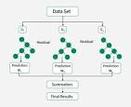
XGBoost (eXtreme Gradient Boosting) is a powerful and efficient machine learning library for supervised learning tasks like regression and classification. It's an ensemble method that sequentially combines multiple weak decision trees to correct previous errors, resulting in a strong predictive model. Key features include optimized performance through regularization, built-in parallel processing for speed, and flexibility, making it a highly effective and popular choice in data science competitions and applications.
How it Works (Gradient Boosting):
XGBoost is built on the foundation of gradient boosting. The core idea is to create a strong model by iteratively adding weak learners (decision trees).
- 1. Initial Model:
A basic model (like a decision tree) is trained to make an initial prediction.
- 2. Error Calculation:
The errors (residuals) that the first model makes on the training data are calculated.
- 3. Next Model:
A new decision tree is trained to predict these errors, effectively learning from the mistakes of the previous model.
- 4. Combining Models:
The predictions of the new tree are added to the predictions of the previous ensemble.
- 5. Repetition:
This process is repeated, with each new tree focusing on correcting the shortcomings of the combined ensemble, leading to a highly accurate final model.
Key Innovations of XGBoost:
- eXtreme Optimization:
The "eXtreme" in its name refers to the focus on pushing the limits of computational resources and performance for boosted tree algorithms.
- Regularization:
XGBoost incorporates regularization techniques to prevent overfitting, which helps to improve the model's generalization to new data.
- Parallel Processing:
It features built-in parallel processing, allowing it to train models on large datasets much faster than traditional gradient boosting methods.
- Scalability and Efficiency:
XGBoost is designed to be a scalable, distributed, and portable library, making it highly efficient for large-scale data science problems.
Why XGBoost is Popular:
- High Accuracy:
It consistently achieves high accuracy on various supervised learning tasks.
- Efficiency:
Its optimized architecture and parallel processing make it very fast.
- Versatility:
It's effective for a wide range of regression, classification, and ranking problems, especially with structured (tabular) data.
- Widely Used:
XGBoost is a staple in data science competitions, such as those on platforms like Kaggle, due to its performance and flexibility.

=================================================================

✅ 5. LightGBM

📘 Definition:
Boosting framework using leaf-wise tree growth for faster training.

🧠 Intuition:
Grows trees vertically (best leaf-first), which reduces loss faster.

🧪 Code:
from lightgbm import LGBMClassifier, LGBMRegressor

clf = LGBMClassifier()
reg = LGBMRegressor()

✅ Advantages:
- Very fast
- Handles large datasets and categorical features

❌ Disadvantages:
- Can overfit
- Leaf-wise growth may cause instability on small data

📈 Use Case:
High-frequency trading, recommender systems

📍 When to Use:
When working with large tabular datasets
=====================================================================

